**Login Screen**

In order for users to gain access to our application, we needed some way of authenticating who they were. This screen is the gateway to the game and is shown in the image below:



Ah-Jeez is inherently a social game. That is, the application is only useful if you have people to play it with. For this reason, we wanted to emphasize Facebook as a method of authentication and data access. Ideally everyone would prefer the one click access Facebook provides over the traditional email option. This is why we decided to place the option so prominently in the home screen of the application. Other than the calls to action, we have minimized the amount of information on the screen aside from the game’s logo, which serves to inform the user which application they are in on their phone.

**Lobby**

The lobby serves as home base for the application. After authenticating, the user will be placed in this screen every time they enter or exit the application. This screen is shown in the images below.

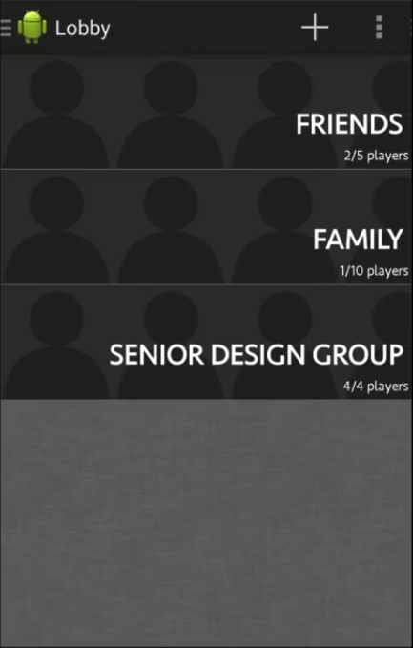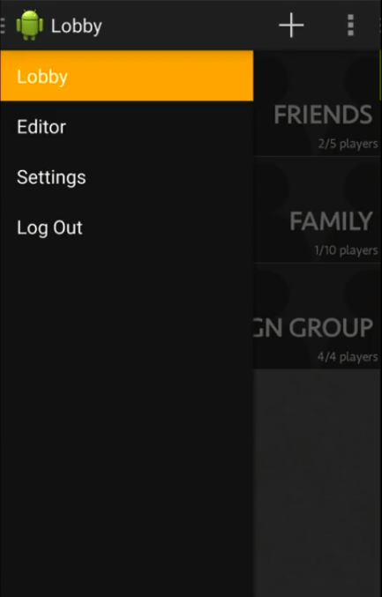

Rooms are where all games begin and end. Therefore, it was only proper that a list of rooms available to the user were the main content of the lobby. This is shown in the left image. In the right image you can see other features of the application. These were intentionally placed in a menu so that they did not distract from the main purpose of the application.

**Room Creation**

One of the features that a player can discover in the lobby is the ability to create rooms. This process is initiated by tapping the “+” button at the top of the lobby. This action will transition the user to the form shown below.

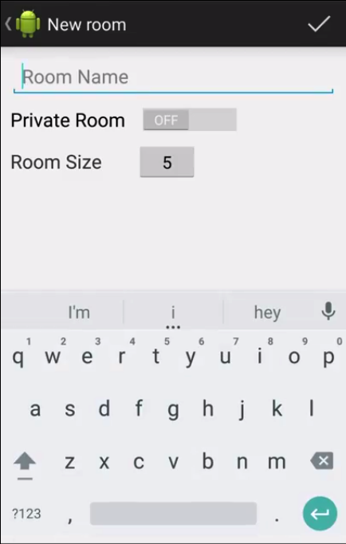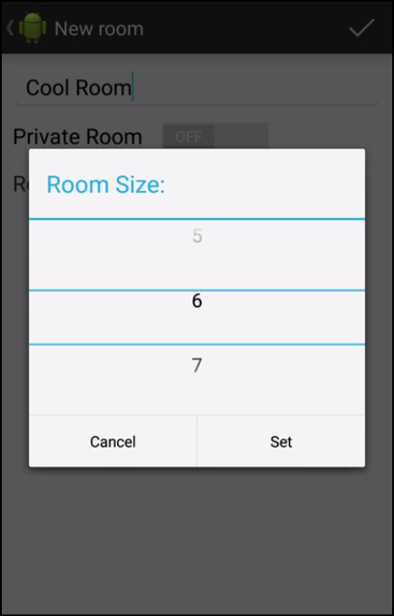

The image on the left is what the user is presented when creating a new room. Rooms only need a name, privacy status, and size in order to be created. This simplicity is reflected in the form. A text field was chosen for the name to allow for variety and uniqueness. Since private rooms were a simple boolean value, a switch was all that was needed to signal whether a room is private or not. Lastly, the room size was represented by a number selection menu shown in the image at the right. This decision was made in order to limit the user to input only integers up to a certain limit. The alternative would require the input to be sanitized and verified. Naturally the number selector was the most fluid option for accomplishing this task.

**Card Creation**

From the lobby, a user can visit the menu and enter a card creation tool. This is process is shown in the images below.

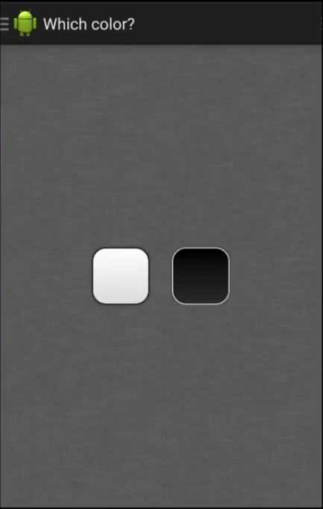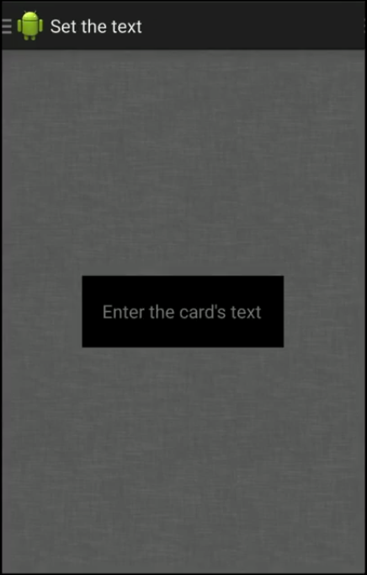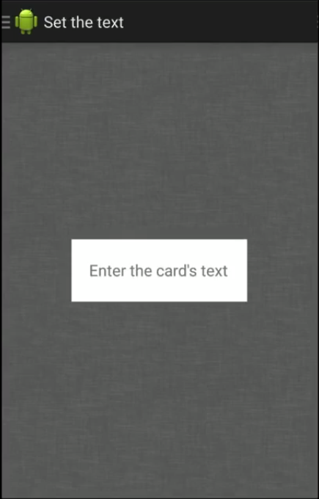

Initially the user enters the screen at the left. the menu at the top calls the user to action. In order to proceed, the user selects which color card they wish to create by tapping the tokens in the center of the screen. If the user chooses black, they are taken to the screen in the middle. If the user chooses white they are taken to the screen on the right. This flow mimics the decision making process of the user, thereby focusing their attention on one detail at a time.

**Game Play**

*PreGame*

After joining a room, the user is placed in a pre-game screen shown below.

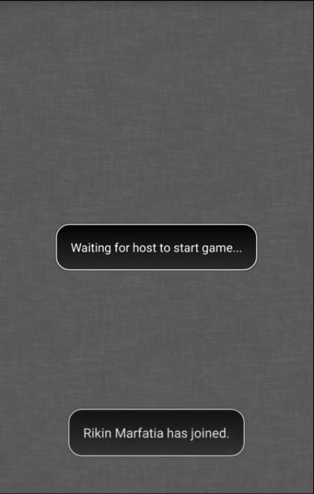

As can be seen from the image, this screen serves as a waiting point for the host to start the game. There are small notifications at the bottom of this screen in order to inform the user of any new players who are entering or leaving the room. This way, the user can keep track of who they are playing.

*Playing A Card*

When the host starts the game or a new round has begun, the player is introduced to their hand and the new black card in the screen shown below.

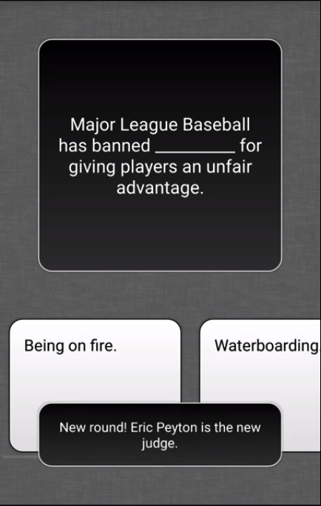

From this screen the user can scroll left and right through their hand in order to view their cards. The black card is always visible in the top two thirds of the screen in order to provide context. Small notifications for when a round begins or player actions are shown temporarily at the bottom in order to provide a wider context of the status of the game. When a user selects a card to play the card is moved forward on the screen as feedback. This is shown below.

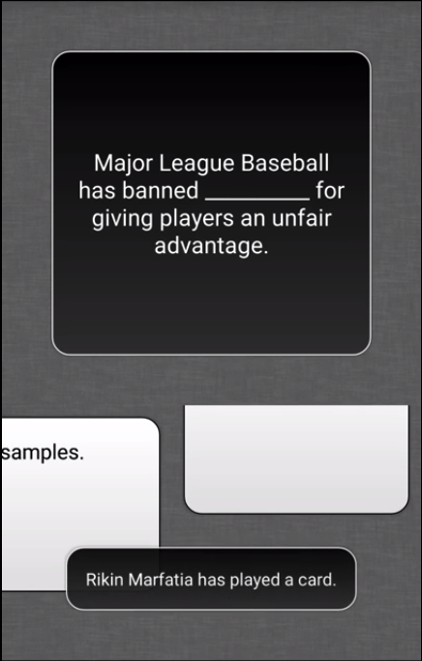

*Playing as the Judge*

At the beginning of each round a judge is selected. When this happens the interface is adjusted in order to reflect the change in role.

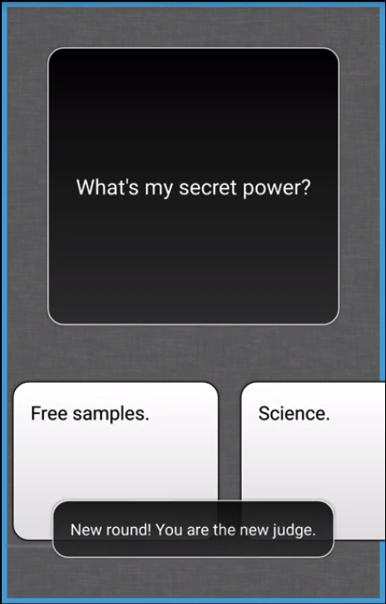

In order to notify the user of this change a notification at the bottom of the screen is displayed indicating the change in role. In addition to this, a blue border is wrapped around the screen in order to remind the user throughout the round. After all of the players have played a card, the judge is presented with the screen below, where he or she can choose the winner.

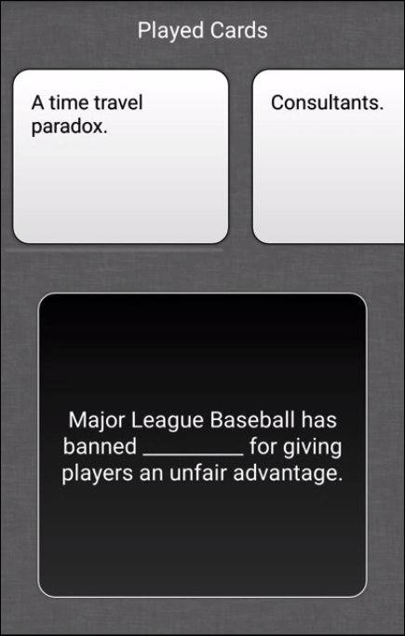

*End of the Round and Game*

After a round ends the user is temporarily placed in a review screen indicating who was the winner and the reward. If someone has accrued enough points to win, the message will be tailored to reflect that. These screens are shown below.

